**EFFICIENT DATA RETRIEVAL**

**A SUMMER INTERNSHIP REPORT**

***Submitted by***

PONKIYA HEPIN RAMJIBHAI

200410116021

***In Partial fulfillment for the award of the degree Of***

**BACHELOR OF ENGINEERING**

***in***

**Information Technology**



Sardar Vallabhbhai Patel Institute of Technology, VASAD.

**Gujarat Technological University, Ahmedabad**

**August, 2023**

**SARDAR VALLABHBHAI PATEL INSTITUTE OF TECHNOLOGY, VASAD.**

INFORMATION TECHNOLOGY ENGINEERING

2023-24



**CERTIFICATE**

**Date: ___/___/2023**

This is to certify that the Summer Internship Work entitled “EFFICIENT DATA RETRIEVAL” has been carried out by PONKIYA HEPIN RAMJIBHAI (200410116021) under my guidance in fulfillment of the degree of Bachelor of Engineering in Information Technology (7th Semester) of Gujarat Technological University, Ahmedabad during the academic year 2022-23.

Internal Guide Head of the Department

Prof.(Parita Parikh) Dr. Mala h. Mehta

Asst. Prof. IT Dept.

SVIT,VASAD SVIT,VASAD

**ACKNOWLEDGEMENT**

I am incredibly grateful to my internship supervisor, Nirav Barot, for their invaluable guidance and support throughout my internship. From the moment I started, Nirav Barot took the time to get to know me and understand my goals for the internship. They provided me with clear direction and expectations, and were always available to answer my questions and provide valuable feedback.

Throughout the internship, Nirav Barot provided me with invaluable insights and advice that helped me to grow as a professional. Their constructive feedback helped me to improve my skills and approach to my tasks, and their encouragement kept me motivated and focused. I am deeply thankful for Nirav Barot’s time and effort, and for their commitment to my success.

**Hepin Ponkiya (200410116021)**

**ABSTRACT**

In the 15 days’ summer training I had studied about WEB DEVELOPMENT Front and Backend. I chose this training because it helps to develop dynamic web pages, and it is useful for my career in Information technology Industry. Under the I learned various new techniques of building websites from basics to advanced which is the very foundation of big problems solved at various levels in the Industry. Apart from that I learned to change the functionalities of complex web pages & make them more efficient by managing lines of code & using the latest technologies. at the end I developed a project called Efficient Data Retrieval A node.js application which helped me solidify my understanding of all the latest tools and techniques learnt .

Table of Contents

ACKNOWLEDGEMENT i

ABSTRACT ii

1 INTRODUCTION 1

2: TOOLS AND TECHNOLOGIES USED 2

2.1: HARDWARE REQUIREMENTS 2

2.2 : SOFTWARE REQUIREMENTS 2

2.3 : JAVASCRIPT 2

2.4 : SQL 3

2.5 : XAMPP 3

2.6 :VS CODE 3

3 :SYSTEM DESIGN 5

4 TECHNICAL CONTENTS 8

5 INTERNSHIP CONTENTS 10

6 USER INTERFACE 12

7 CONCLUSIONS 17

8 REFERENCES 18

**1: INTRODUCTION**

**1.1 Background and Purpose:**

The 15-day online internship on "Efficient Data Retrieval" was designed to equip participants with practical skills in implementing efficient data retrieval techniques using a stack of technologies including JavaScript, SQL, HTML, CSS, and Node.js.

**1.2 Objectives:**

The primary objectives of the internship were to gain hands-on experience in developing web applications, learning about database management using MongoDB, and applying efficient data retrieval techniques using JavaScript and Node.js.

**1.3 Technologies Used:**

The internship revolved around technologies including JavaScript for scripting, SQL as a Structure database, HTML and CSS for front-end development.

**2: TOOLS AND TECHNOLOGIES USED**

**2.1: HARDWARE REQUIREMENTS**

• Pentium-IV(Processor) Or any processor.

• 256 MB Ram OR Above

• 512 KB Cache Memory

• Hard disk 10 GB or above

• Microsoft Compatible 101 or more Key Board

**2.2 : SOFTWARE REQUIREMENTS**

• Operating System : Windows 95/98/XP with MS-office or above.

• Programming languages : SQL, JavaScript.

• IDE : VS Code

**2.3 : JAVASCRIPT**

JavaScript often abbreviated as JS, is a programming language that conforms to the ECMA Script specification. JavaScript is high-level, often just-in-time compiled, and multi- paradigm. It has curly-bracket syntax, dynamic typing, prototype based, object-orientation, and first-class functions.

Alongside HTML and CSS, JavaScript is one of the core technologies of the World Wide Web. JavaScript enables interactive web pages and is an essential part of web applications. The vast majority of websites use it for client-side page behavior, and all major web browsers have a dedicated JavaScript engine to execute it.As a multi-paradigm language, JavaScript supports event-driven, functional, and imperative programming styles. It has application programming interfaces (APIs) for working with text, dates, regular expressions, standard data structures, and the document object model (DOM). However, the language itself does not include any input/output(I/O), such as networking, storage, or graphics facilities, as the host environment (usually a web browser) provides those APIs.

**2.4 :SQL**

SQL (Structured Query Language) is a specialized programming language designed for managing and manipulating relational databases. It allows users to communicate with databases to perform tasks like retrieving, inserting, updating, and deleting data. SQL provides a standardized way to interact with databases, regardless of the specific database management system (DBMS) being used.

**2.4 :XAMPP**

XAMPP is a software package that makes it easy to set up a local web server on your computer. It includes essential components like Apache (for serving web pages), MySQL (for databases), PHP (for dynamic web content), and more. XAMPP is great for web developers to create and test websites without needing an internet connection. However, it's not recommended for live websites due to security and performance reasons.

**2.5: VS CODE**

Visual Studio Code is a source-code editor developed by Microsoft for Windows, Linux and macOS.It includes support for debugging, embedded Git control and GitHub, syntax highlighting, intelligent code completion, snippets, and code refactoring. It is highly customizable, allowing users to change the theme, keyboard shortcuts, preferences, and install extensions that add additional functionality. The source code is free and open source and released under the permissive MIT License. The compiled binaries are freeware and free for private or commercial use.

Visual Studio Code is based on Electron, a framework which is used to deploy Node.js applications for the desktop running on the Blink layout engine. Although it uses the Electron framework, the software does not use Atom and instead employs the same editor component (codenamed "Monaco") used in Azure DevOps (formerly called Visual Studio Online and Visual Studio Team Services).

In the Stack Overflow 2019 Developer Survey, Visual Studio Code was ranked the most popular developer environment tool, with 50.7% of 87,317 respondents claiming to use it.

## 

## 3: SYSTEM DESIGN

* 1. **Use Case Diagram**

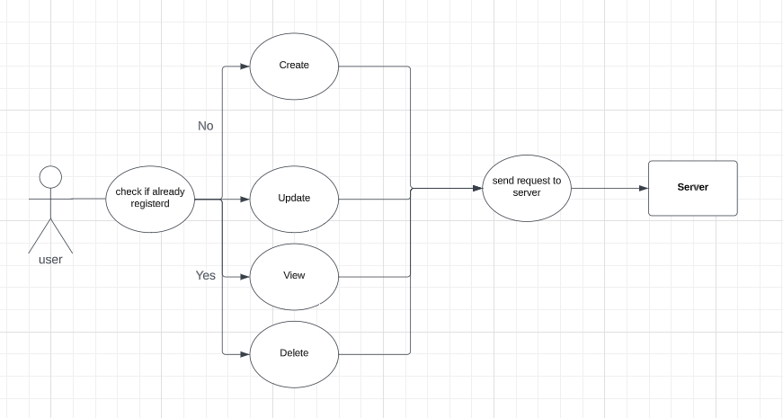

### 3.2 Class Diagram

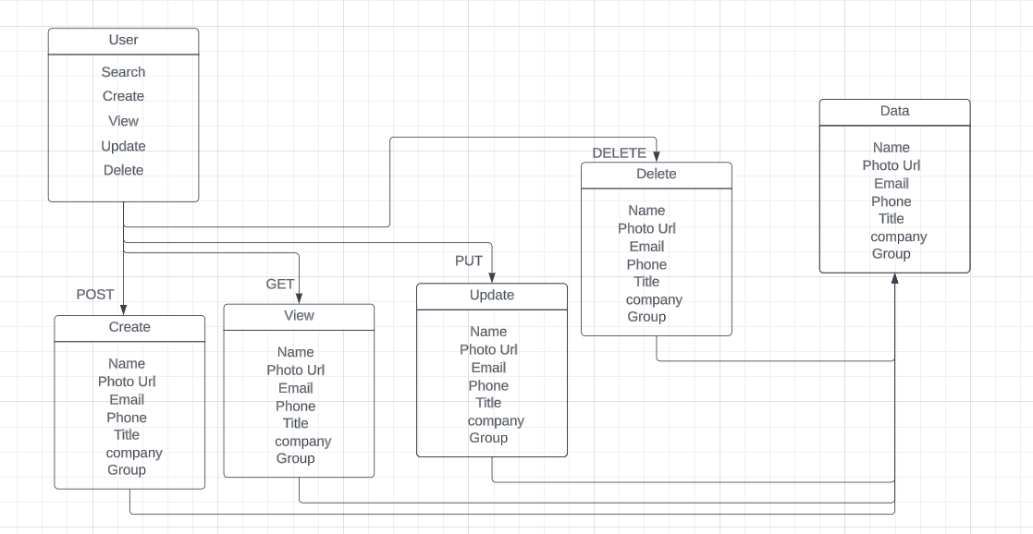

### 3.3 Sequence Diagram

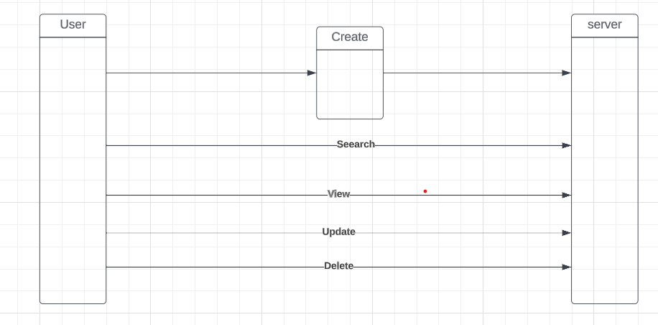

* 1. **Activity Diagram**

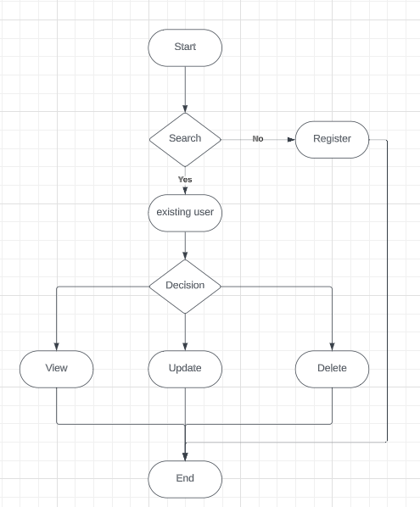

## 4: TECHNICAL CONTENTS

**1) Getting hold on development basics**

The course covered various basic Topics like how one should and can follow the path of being a full stack developer from basics to advanced level . A lot of problems were solved based on basic knowledge & it’s implementation rather than just memorizing stuff .

**2) HTML & CSS**

This includes covering commonly used HTML tags. We can refer to MDN Docs as well quite early in the course as a reference material. Overall this is a small section which gets completed soon. We got skimmed through CSS section. There is lot of ground to cover in CSS. We got to learn about Specificity and Cascade, Selectors, Fonts etc. There were 2 projects to give a practical experience in writing CSS.

**3) Bootstrap**

This is a huge section where we learn about various Bootstrap(latest version) components such as navs, grids, forms. There is a image gallery project using Bootstrap which was cool.

**4) JavaScript**

JS lessons were very good. Syntax, Control Flow, Functions, Arrays, Object Basics were taught in great detail. (Almost 8 hrs content in 40 hrs course). This is mainly because whole backend section rests on JS foundations taught in these sections. There are various tiny coding exercises and quiz to hammer home the JS concepts.

**5) DOM Manipulation**

This was very good and most interesting part of the course. DOM manipulation was taught using vannila JS with methods such as querySelector, querySelectorALL, addEventListner etc.

**7) Express**

This begins with a simple express app, package json file, route params, basic exercise. Colt uses 'ejs' or embedded JavaScript to render view templates.

**8) Database (SQL)**

We got a brief introduction to SQL, Using xampp and connection with database etc. Further about how to integrate with data to create various table, users, comments etc.

**5: INTERNSHIP CONTENTS**

**1) Basics & Logic building**

• Path to be a full stack developer

• Installation & basics

• VS Code local environment set up

**2) Front End**

• HTML

• CSS

• JavaScript + jQuery

• Bootstrap

**3) Advanced Front End**

• SemanticUI

• Advanced DOM Manipulation

**4) Back end**

• Mysql

• XAMPP

• Express JS

**5) Advanced Back end**

• REST API

• Database Associations

• Authentication

• Authorization

**6) Main Project concepts**

• Efficient Data Retrieval

• Maintenance

**6: USER INTERFACE**

**Start Page :-**

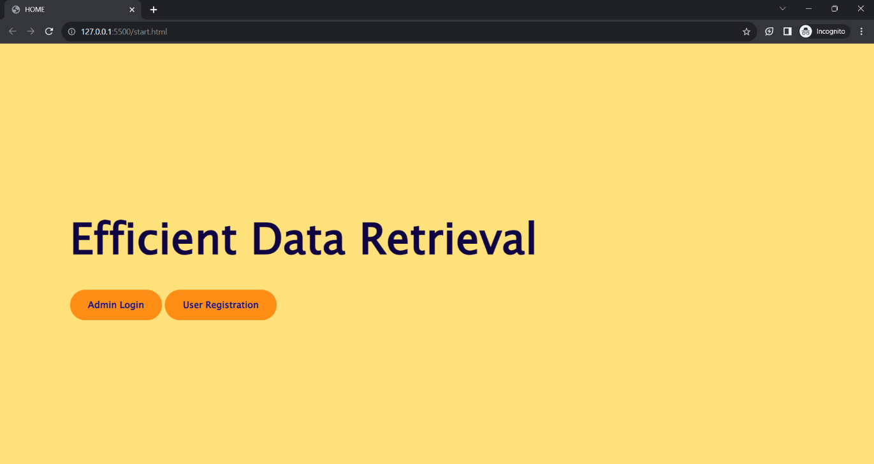

**Home Page :-**

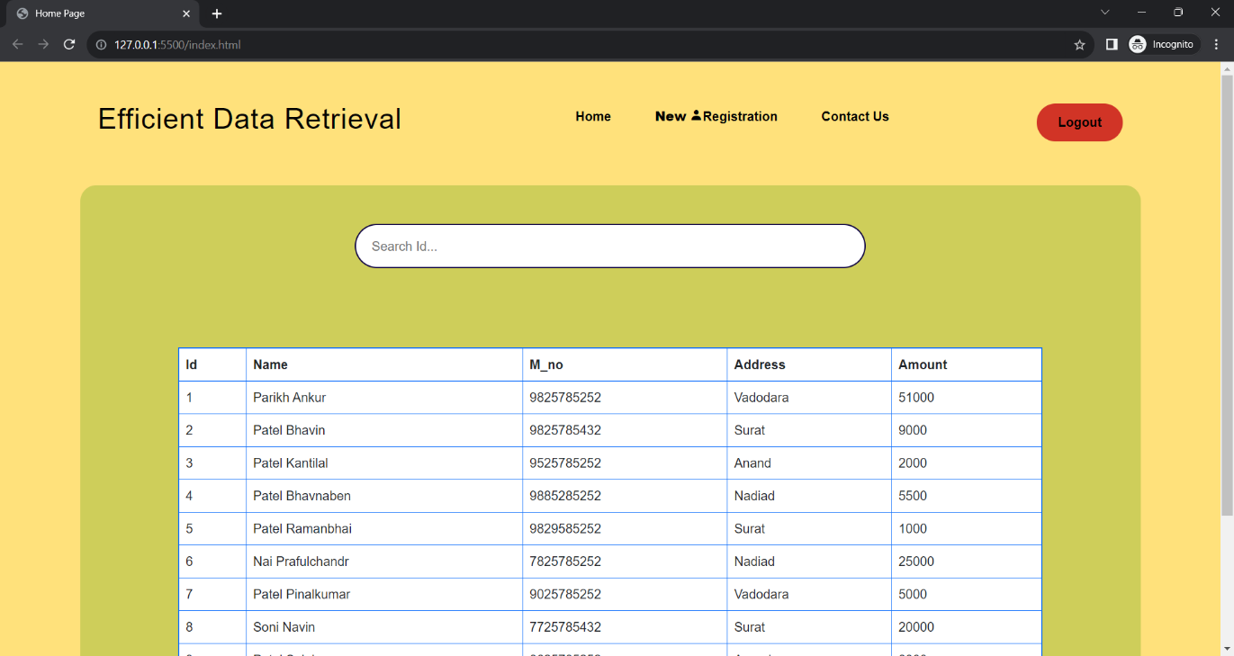

**After Search :-**

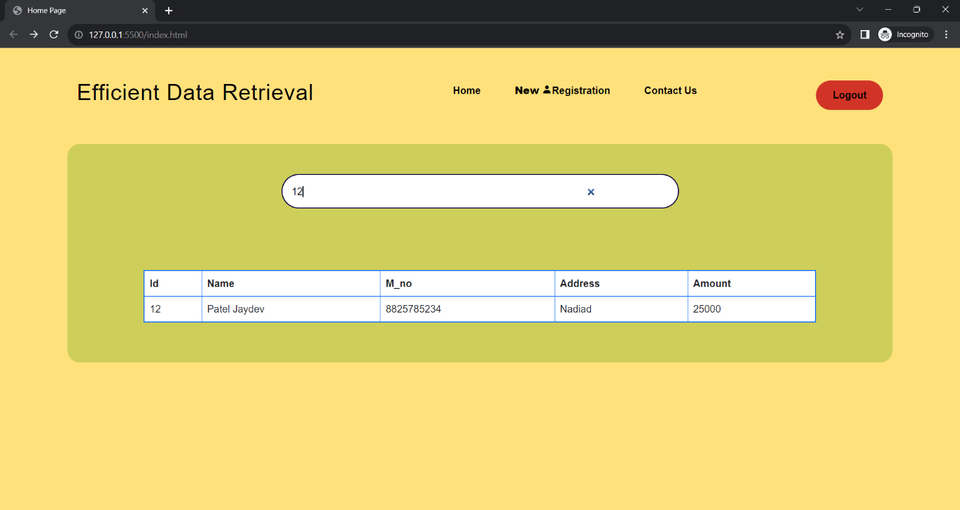

**Not Found! :-**

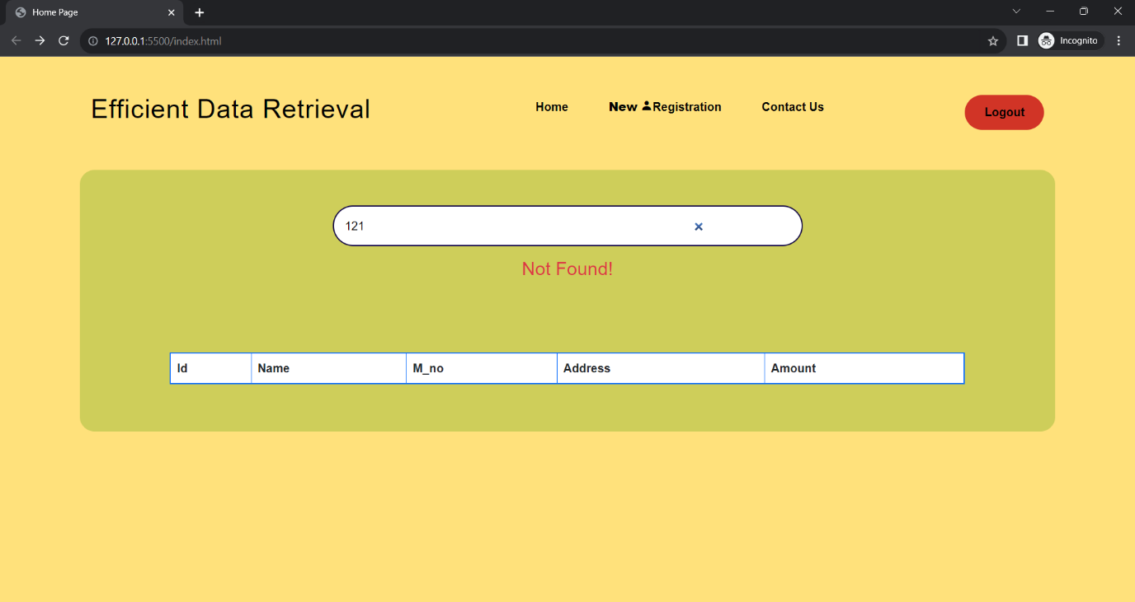

**Contact US:-**

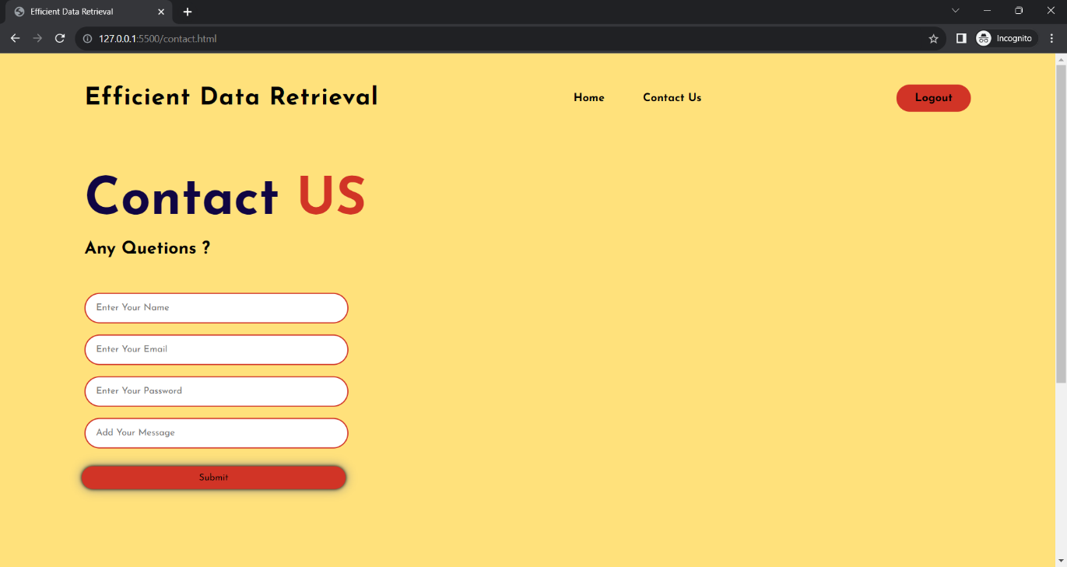

**Admin Login Page :-**

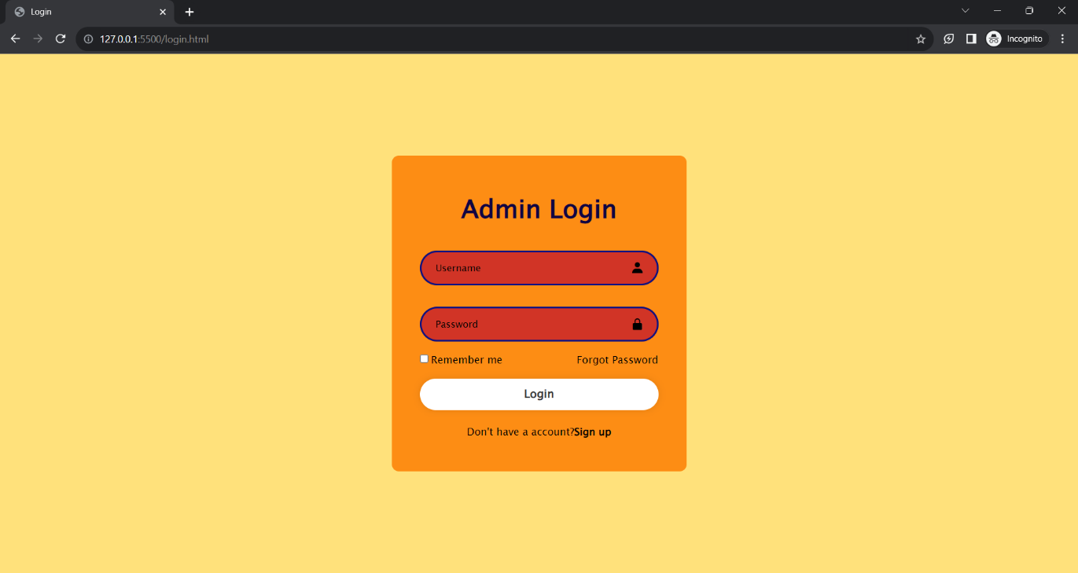

**Sign up Page :-**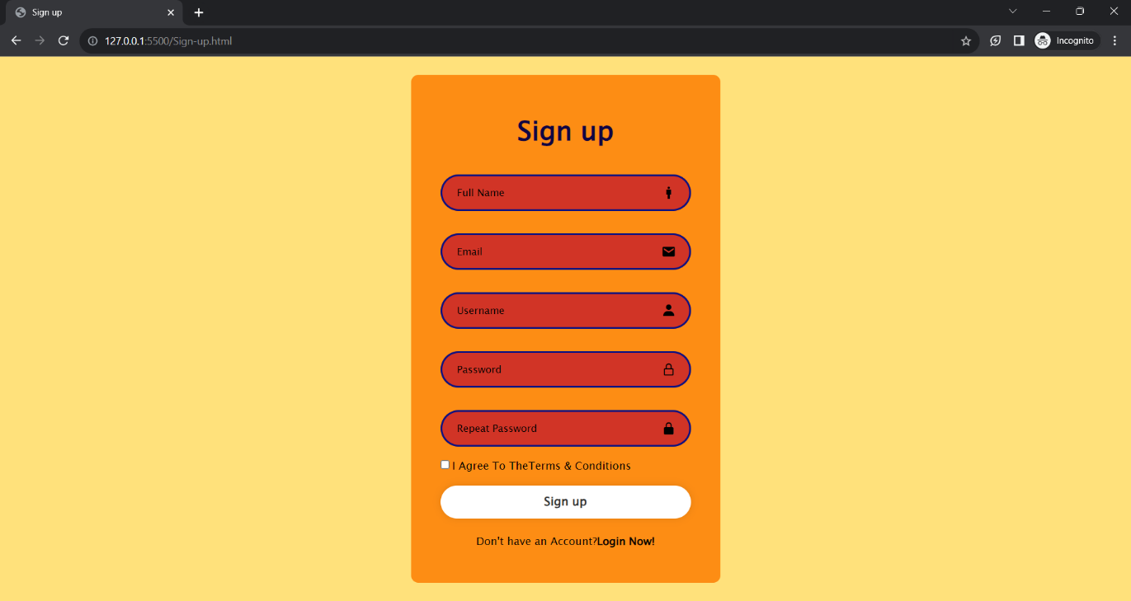

**User Registration :-**

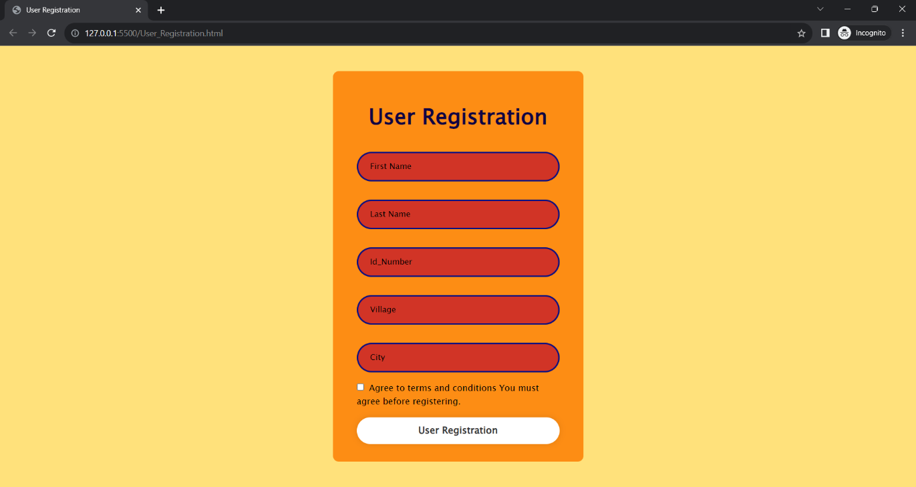

**Error 403 Page :-**

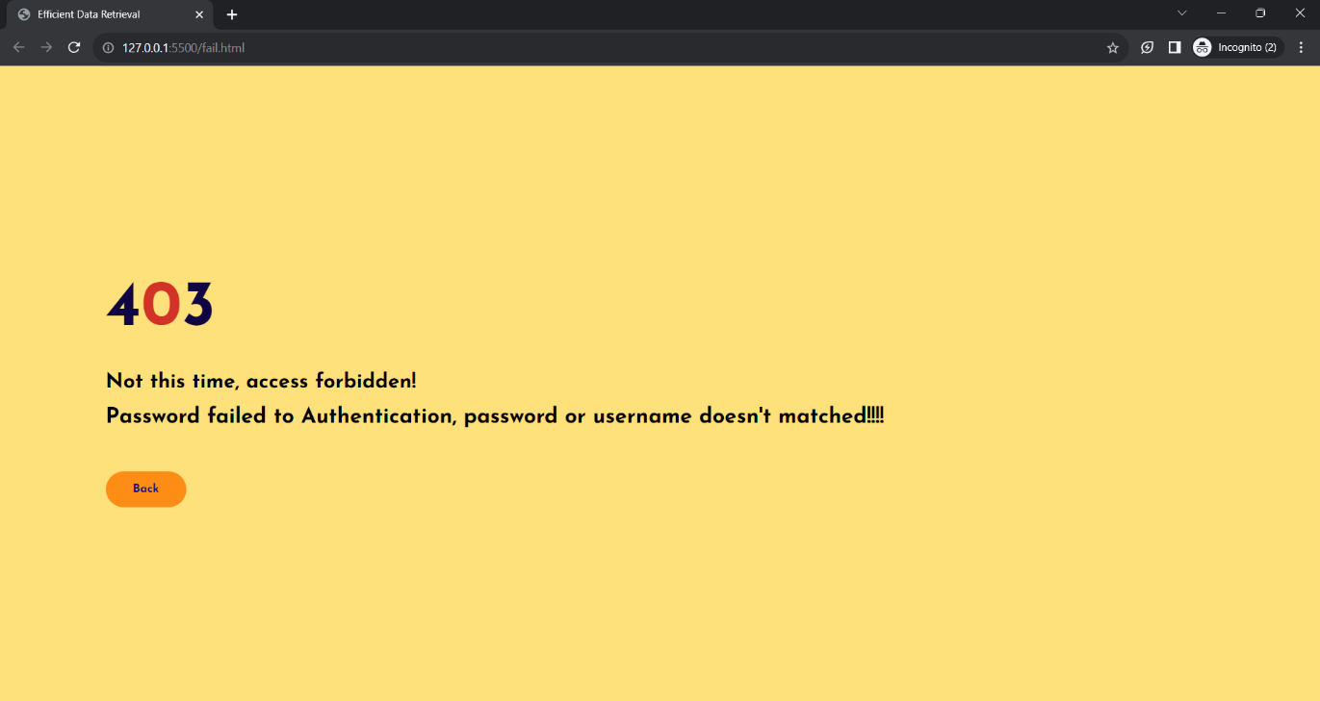

**7: CONCLUSION:**

**7.1 Reflection on Online Internship Experience:**

The online internship provided a unique learning experience, demonstrating the potential of remote learning and skill development.

**7.2 Acknowledgments:**

Heartfelt thanks to Nirav Barot for their guidance and support throughout the online internship journey.

**7.3 Personal and Professional Growth:**

The internship contributed to personal growth by enhancing technical skills, adaptability, and fostering virtual collaboration capabilities.

**8: REFERENCES:**

List the online resources, tutorials, webinars, books, and other references used during the online internship for research and learning.